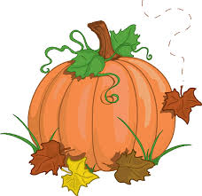
November 2019

SUNDAY | MONDAY | TUESDAY | WEDNESDAY | THURSDAY | FRIDAY | SATURDAY
 |  |  |  |  | 1 PE  It’s Baking season | 2
3 | 4 Music  Letter “Hh” | 5 Who lives in our  homes? | - 6 Computer  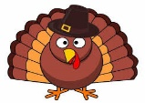  Thanksgiving  Turkeys | 7 PE  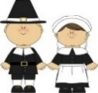  Pilgrim Boys and Girls | 8  NO SCHOOL | 9
10 | 11  NO SCHOOL | 12  There Was An Old  Lady  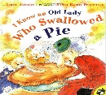 | 13 Computer  Letter “Ii”  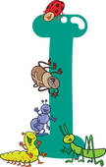 | 14 PE  We Love Our Families | 15 PE | 16
17 | 18 Music  Letter “Jj” | 19 We are Thankful  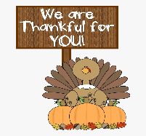 | 20 Computer  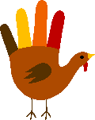  November handprint | 21 PE  Sequencing fun! | 22 PE  Getting our tree | 23
24 | 25 Music  We Love Santa | 26  Thanksgiving  Snack- Friendship fruit salad | 27  NO SCHOOL | 28  Happy Thanksgiving! | 29 | 30

