May 2019

SUNDAY | MONDAY | TUESDAY | WEDNESDAY | THURSDAY | FRIDAY | SATURDAY
 |  |  | 1 Computer/Music  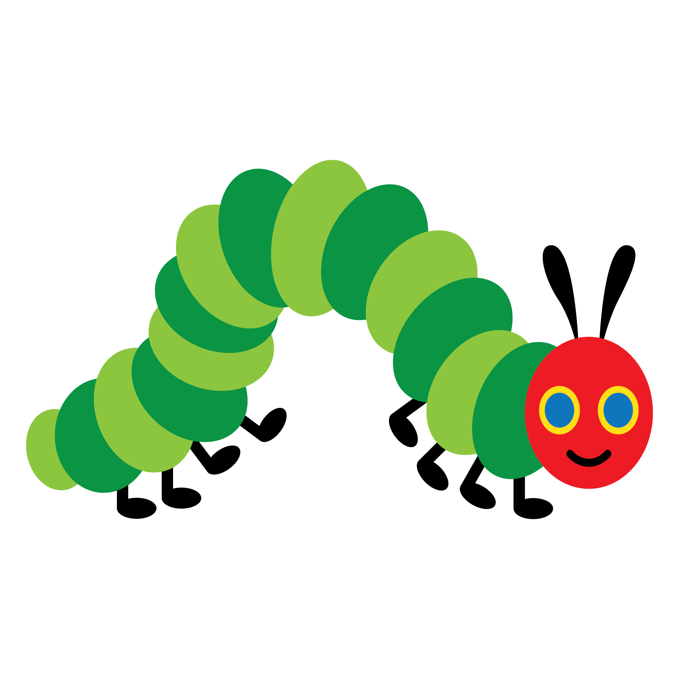  Caterpillars | 2 PE  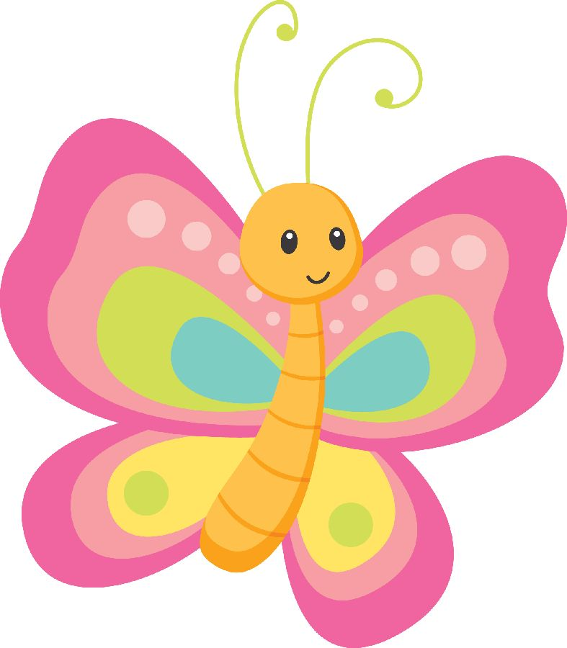  Symmetrical  Butterflies | 3  Letter “Ww” | 4
5 | 6 PE  “My Mom” story writing | 7 Letter “Xx”  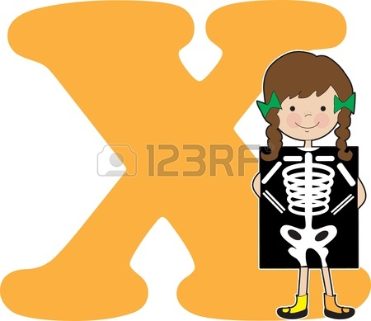 | 8 Computer/Music  We Love Our Moms! | 9 PE  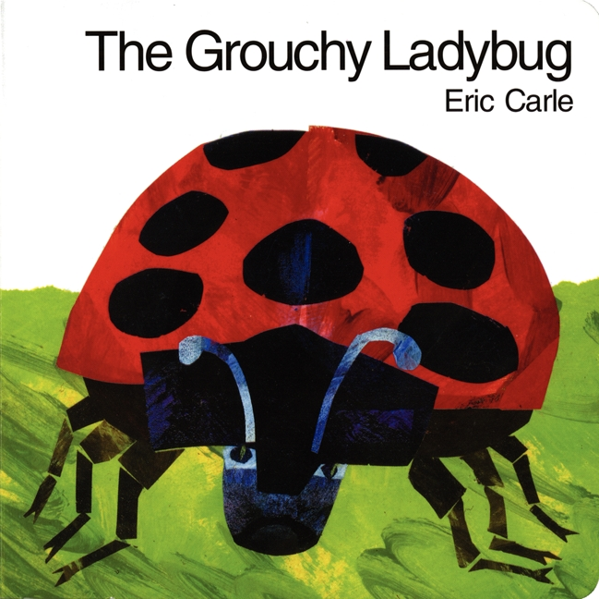  The Grouchy Ladybug | 10  Painting Fun! | 11
12 Happy Mother’s Day! | 13 PE  Letter “Yy” | 14  Creating Memories! | 15 Computer/Music | 16 PE | 17  Spring Flowers | 18
19 | 20 PE  Letter “Zz”  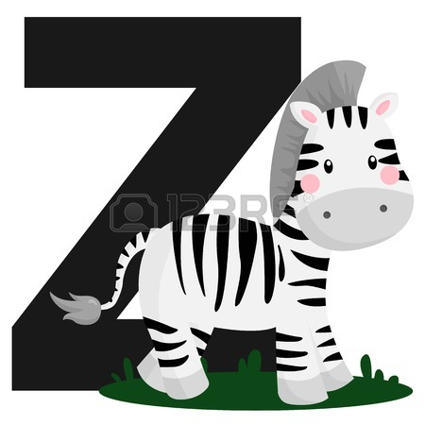 | 21  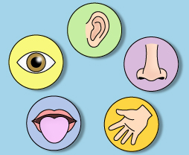  My 5 Senses | 22 Computer/Music  Handprint book and  poem | 23 PE  Good Night Gorilla | 24  NO SCHOOL-  MEMORIAL DAY | 25
26 | 27  NO SCHOOL- MEMORIAL DAY | 28  Fireflies | 29  NO SCHOOL- Kindergarten Orientation | 30 PE | 31

