December 2018

SUNDAY | MONDAY | TUESDAY | WEDNESDAY | THURSDAY | FRIDAY | SATURDAY
 |  |  |  |  |  | 1
2 | 3 PE  Wrapping Fun! | 4  Christmas Trees | 5 Computer/Music  Candy Canes | 6 PE (aftn.)  December handprint  Night Tree celebration 6:00 pm | 7  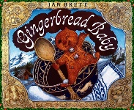  Gingerbread Baby | 8
9 | 10 PE  Gingerbread Houses | 11  Gingerbread Roll and Write | 12 Computer/Music  Santa’s Stuck | 13 PE (aftn.)  Christmas Lights book | 14  Christmas Concert at 10 am in Church! | 15
16 | 17 PE  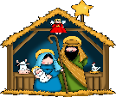  Nativity Scenes | 18  Dear Santa….. | 19 Computer/Music  Cookie  decorating and  Christmas  Celebration! | 20 PE (aftn.)  We Love our  Families! | 21  Game Day! | 22
23  30 | 24  NO SCHOOL  31 | 25 Merry  Christmas to all! | 26 | 27 | 28 | 29  See you all on Wednesday,  January 2nd!

